Miniture Hyperloop Prototype  
Project Proposal -FInal Year Project

M.L. Hariras Tongyai

# Overview

## Project Background and Description

The Hyperloop: The fifth mode of transportation is an open-source idea prop ose by the futurist Elon Musk as an alternative mode of transportation to the California High Speed rail project which does not offers any innovative ideas along with indifferences in terms of reduction of both travel time, cost and efficiency. The Hyperloop will between Los Angeles and San Francisco in only 30 minutes with a total estimation of 840 passengers per hour (28 passengers every 30 seconds).

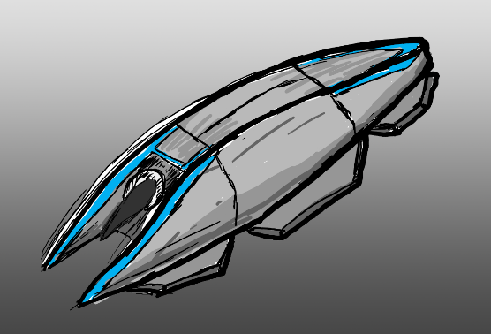

**Hyperloop Pod Concept Sketch Figure .1**

My fascination with the Hyperloop concept is the use of simplistic systems to implement an innovative solution of channeling air resistance and pressure through the hyper loop pod to achieve an aircushion lift and proportion to minimize friction and resistance in motion within a low pressure or near vacuum tubing. (For Technical approach refer to the “Approach taken section”). The Hyperloop pod is a self-contained pod which handles levitation and propulsion with a single air compression system and will be the main focus of the proposing project.

As an open-source idea, many organizations, private companies, government agencies, universities and student group have formed R&D projects and competitions based on this concept which resulted in multiple variation of the Hyperloop system ranging from the use of the original concept of “Air Bearings” to the use “Electromagnetic suspension”. However, from this detailed initial research I hope to devise and implement my own approach to the Hyperloop concept and build a miniature system demonstrating the system outlined in this project proposal.

This proposal contains research from:

* Elon Musk’s Original Hyperloop Alpha’s Proposals.
* Hyperloop Pod Sizing model conceptualization by the Nasa Glen Research Team (Cleveland, OH).
* SpaceX’s Hyperloop Test-Track Specification Documentation (From Hyperloop Solutions Competition Testing) February 18, 2016.
* Hyperloop One – Progress
* Hyperloop Technologies - Progress
* Research and Development by Hyperloop Makers UPV Team – Participated in SpaceX Track Test

## Feasibility

The feasibility factor of the project will be judge by the following factors:

* Cost under £100.
* Appropriate approach.
* Self-contained design.
* Time to build no more than 4 Month.
* Demonstration Simplicity & Convenience
* Able to reflect real world applications and implications

*Detailed Documentation on the criteria available in Detailed proposal.

## Approach

The approach I will take for the different element of this project:

* 3D Printed CAPSULE with Miniature Motors & battery (Air Bearing Version)
* Wifi Enabled Microcontroller for wireless control
* 1-meter flexible tubing determining this diameter of the capsule
* Model Potential System
* Reflect and evaluate real-world use.

## Cost Estimation

After an extensive research and 3D Printing quotes from Shapeways, Ponko and Maker’s Café, depending on the complexity of the design the cost for the pod itself can be compress to under £50 as the pod will be a self-contained design leaving the result of the estimated £100 budget to:

* £10 for Motors
* £5 for battery
* £20 for Microcontroller
* £15 for a meter-long tube.

*Extensive Estimation in the Detailed Proposal.

## Extended Resources to back this proposal

Resource Collected, written, design and simulated for this project:

* 3 different CAD (.stl) Models of capsule created
* Sketch and Design for Airflow drew in 3D VR with Tilt brush to simulate the lift and propulsion
* Research on suitable components:
  + Motors
  + Tubing
  + 3D printing quote
  + alternative Manufacturing method.
* Multiple capsule Design.
* Multiple propulsion and lift system research.
  + Air Bearing
  + MagLev